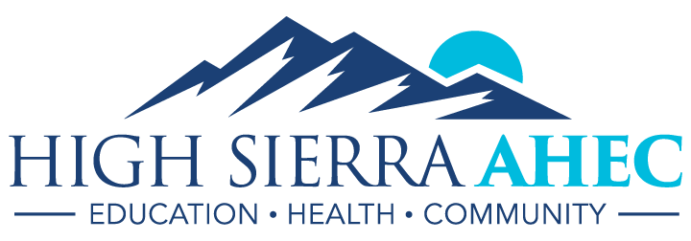
20 March 2017

Dear Community Partner,
High Sierra AHEC is a small public health non-profit that focuses on preparing upcoming health professionals and promoting health and wellness within the Northern Nevada community. An affiliate of the University of Nevada, Reno, School of Medicine, our team is small but mighty. We are able to accomplish so much due in part to our team of volunteer Student Ambassadors. Ambassadors are local community college and university students enrolled in undergraduate programs that lead either to entry- or skilled-level health care positions, or prepare the student for further education and training, such as pre-medical and pre-nursing programs. The mission of our Student Ambassador program is to create a community of diligent, enthusiastic leaders who promote the mission of High Sierra AHEC: health care workforce distribution and diversity, and transformation of health care delivery.
Sponsorship dollars will specifically support a two-day Pre-Professional Health Care Workforce conference created by and implemented by Student Ambassadors for fellow students in the health sciences. Funding will offset marketing and hosting costs, including a networking keynote dinner that encourages inter-professional dialogue and mentorship. This support will make it possible for HS AHEC to offer no-cost conference attendance for students, increasing its accessibility. Contingent upon funding, we aim to continue to build rural partnerships by inviting a select number of students from Western Nevada College and Great Basin College and financing their travel, room, and board for the duration of the conference.
By expanding such dialogue to an undergraduate audience, we will be preparing these future professionals for the challenges and rewards of working in health care. This conference will feature local healthcare leaders and educators, providing opportunities for education and skills workshops. Ambassadors will gain experience and a greater understanding of the importance of inter-professional work environments and topics such as ethics, cultural competency, and patient-provider interactions. High Sierra AHEC is confident that this will be an impactful way to help prepare the upcoming generation of health care professionals. With the success of this event, we endeavor to implement the Pre-Professional Health Care Workforce conference as an annual function, and so remaining sponsorship dollars will be saved to continue programming for next year. HS AHEC will ensure that your organization be thanked and acknowledged not only as a sponsor of this event, but also as a community partner and an agency leading health care transformation. We are grateful for your support and confident that we can collectively strengthen and improve the health care workforce of Northern Nevada!
Included in this packet is further information about the Student Ambassador program and promotional and marketing materials for general HS AHEC operations, as well as a for other programs Student Ambassadors help facilitate. For more information, please contact Andrea Gregg, Executive Director of High Sierra AHEC, at (775) 410-2717 or by email andrea@highsierraahec.org.
To make a tax-deductible donation and to learn more about our individual Ambassadors, please visit our Go Fund Me campaign: https://www.gofundme.com/hsahec
We look forward to hearing from you!
Sincerely,
High Sierra AHEC Staff and Student Ambassadors

High Sierra AHEC Student Ambassador Program

Program Update: July 2016-March 2017
- The Student Ambassador (SA) Program continues to be successful and impactful to HS AHEC operations.
  - Total recruitment over time of active ambassadors based upon semester-long commitments:
    - January 2016 (launch/spring): 9
    - December 2016 (fall): 12
    - March 2017 (spring): 18
Factoring in graduation rates, the average retention between semesters is 75%.
  - Comprehensive expectations can be found in the SA Contract (Attachment A) and include the following:
    - Assistance with a minimum of 3 HS AHEC events per semester;
    - Participation in monthly Ambassador meetings;
    - Participation in activities and events related to health care career awareness, workforce development programs, and community health and wellness.
    - Letter of intent upon completion of the program
- Programmatic Growth and Development:
  - Community Partnerships
    - UNR Center for Student Engagement:
HS AHEC now partners with the Center for Student Engagement primarily as a marketing and recruiting platform through Give Pulse, an online volunteer opportunity hub. In this way, we have further access to campus resources and a larger pool of civically-minded students, as well as student transportation (if needed).
    - Valuable Opportunities in Interprofessional Collaboration and Education (VOICE)
HS AHEC’s partnership with VOICE will benefit Student Ambassadors by providing a platform for open discussion and opportunities for hands-on learning via this student-driven initiative.
  - Student-led Outreach Initiatives
    - The Pre-Professional Healthcare Workforce Conference was originally the brain child of former Ambassador Sasha Ortega and is now led by a group of 6 Ambassadors.
- Fall 2016 (August-December)
Ambassadors assisted with and/or led the following events:
  - Classroom-based Outreach
    - Project Prevent at Reed HS: 27 Students
    - Project Prevent at Hug HS: 30 students
    - Discovering Health Careers at Reed HS: 30 Students
    - CTE Career Expo (Operation Healthcare Bound): 750 students
  - Pre-Professional Healthcare Workforce Conference
    - Ambassadors volunteered to participate on this planning committee, and have assisted in achieving the following:
      - Event planning and design
      - Ideal speaker schedule and primary outreach initiatives, including speaker registration
      - Event fundraising
        - Kim Crandell, Director of Business Development at Carson Tahoe Health, provided feedback and guidance to Ambassadors Christian and Austin, to develop a sound sponsorship pitch.
        - General SA Sponsorship Tier development
  - Professional Development
    - Nevada Health Conference
    - Women As Change Makers Conference
    - Once a semester Health Care Workforce Discussions with guest speakers
October 2016: Erin Eddings, Case Management worker from Northern Nevada Hopes
Board members are invited to volunteer as guest speakers to discuss topics that relate to the healthcare workforce and other related topics.
    - Complimentary access to a course through the Online Learning Portal
- Survey Results
Upon completion of the fall semester, Ambassadors were asked to fill out an anonymous survey of the SA Program; 6 out of the 12 Ambassadors completed the survey. The results are as follows:
Category | Rating out of 5
“I felt that HS AHEC provided beneficial challenges.” | 4.7
“I receive the right amount of recognition and acknowledgment from HS AHEC staff.” | 4.7
“I felt confident that HS AHEC staff would give direction and feedback when necessary.” | 4.7
“I appreciated and worked well with other Ambassadors.” | 4.5
“Overall, my work experience with AHEC was satisfying and rewarding.” | 4.7
85% of Ambassadors who completed the survey intend on returning.
Suggestions:
- A stronger mental health focus
- Offering a program to high school students similar to the Big Sister, Big Brother [program] to offer extra support
- More community volunteer work
- I enjoyed the Project Prevent events and would like to see more individualized and personalized lesson plans if possible to maybe branch out into more diverse topics.
- I think AHEC offers an overall well rounded program. I would like more interpersonal meetings to engage with the team more. And maybe brainstorming sessions to think of new ideas to spread the word about health. Additionally I loved the guest speaker series! More more more of those!
Comments:
- “Very happy with my HS AHEC experience. I learned so much and got to give back and spread the message of health. I would not have had the opportunities I have without this program and I hope to bring others on the team as well.”
- “As long as I'm in Reno, I plan on continuing to volunteer with AHEC.”
- “AHEC provided me with challenges and tasks that I wouldn't normally see during school. With their help, I learned how to complete the task.”
- “Being a High Sierra AHEC Ambassador is one of those opportunities you were not sure of when first starting, but made you glad you stayed as time went on. The people are great and inspiring and it's a truly humbling experience”
- “Teaching at Hug high school really pushed me out of my comfort zone but was a very rewarding experience. It was interesting to see what the students already knew, and areas they were interested in learning more about. The students taught me a lot, and I learned a lot of valuable lessons through project prevent.”

- Spring 2017 (January-May)
Ambassadors have assisted with or will assist/lead with the following:
  - Classroom-based Outreach
    - Cultural Competencies in Healthcare: 360+ students
    - Carson High School Career Fair: 200+ students, interaction with 30-50 individuals.
  - Discovering Health Care Careers Camps
    - CSI: The Science of Justice, March 20-24th
    - Projected Summer 2017 involvement includes Health Care Heroes and CSI: The Science of Justice
  - Professional and Programmatic Development:
    - Pre-Professional Healthcare Workforce conference
January-March, 2017
      - Ambassadors volunteered to participate on this planning committee, and have assisted in achieving the following:
        - Recruitment of 28 guest speakers/panels
        - Fundraising initiatives totaling $5570, exceeding the initial $5000 goal.
        - Promotion and marketing to prospective student attendees, including:
          - Campus marketing at UNR and TMCC
          - 17 individually-led in-class presentations
          - Instructor-approved online announcements and extra credit assignments
          - Social media outlets
    - Nevada Speech-Language Hearing Association Conference: IPE
    - Northern Nevada Hopes Tour
    - Once a semester Health Care Workforce Discussions with guest speakers
March 2017: Suzanne Norris, Chemistry/Point of Care, from Northern Nevada Medical Center
Board members are invited to volunteer as guest speakers to discuss topics that relate to the healthcare workforce and other related topics.
    - Bonus/Added Value:
      - Various public health-related webinars and trainings
      - Women’s Summit at UNR
      - Nevada System of Higher Education Diversity Summit
      - Spanish for medical needs course
      - Complimentary access to a course through the Online Learning Portal

Student Ambassador Achievements
Since January 2016, Student Ambassadors have completed over 325 hours of volunteer work in the first year of implementation, reaching over 2,500 K-12 and college students in Northern Nevada, and visiting 8 community partnership sites. Ambassador ingenuity has led to increased teamwork, greater community collaboration, and an emphasis on inter-professional education and professional development for upcoming health professionals via a student-driven Pre-Professional Healthcare Workforce Conference. Through HS AHEC events and initiatives, Ambassadors are engaged in discussion about socioeconomic influences on health and relevant community trends, as well as cultural competency and practice trends to be prepared for. Through the success of this program, we are confident that we can collectively strengthen and improve the upcoming health care workforce of Northern Nevada.

Future Goals and Objectives
- Expansion and Retention
  - Retention and Recruitment
    - Recruitment strategies include:
      - Target college nontraditional, underserved, and upper-class (junior/senior) students, as well as medically-minded clubs and organizations at both TMCC and UNR.
      - Continue collaboration with the Division of Health Sciences at UNR
      - Continue collaboration with the UNR Center for Student Engagement
    - Strategize implementation for SA cluster groups in rural community colleges, include Great Basin CC and Western Nevada CC, in partnership with the Nevada AHEC network.
    - Retention Strategies:
      - Continue to offer added benefit events and activities for personal and professional development
      - Acknowledge and reward Ambassadors
        - Program Materials contingent upon funding
        - Continue newsletter acknowledgement of accomplishments
        - Letter of Recognition from BOD
  - Future events/tasks:
    - Continue classroom-based outreach, specifically within Title 1, at-risk schools
    - Interprofessional Education Day in collaboration with VOICE
    - Project Prevent and Project Prevent 2.0 edits, facilitation, and implementation
    - Assistance with HPV-related materials and special projects, when applicable

    - The 2nd Annual Pre-Professional Healthcare Workforce Conference (Spring 2018)
- Added Benefit Activities and Opportunities for Professional Growth and Development
These will continue, contingent upon and modified according to availability, student schedules, and financial capability of HS AHEC.
- 2nd Annual Pre-professional Health Care Workforce Conference*
We endeavor to implement a second conference opportunity for Spring 2018, improving upon the 2017 event and feedback.
*Contingent upon funding
- Working within NAO Objectives for FY 17-18
  - Objective 1: Preparing a Diverse Workforce
    - Recruitment and outreach activities will focus on diversity, and rural and underserved populations to the capacity that Ambassadors are able to attain.
  - Objective 2: Improving Workforce Distribution
    - HS AHEC will continue to partner with underserved communities when coordinating SA events so that Ambassadors may become more involved in these communities as well as promote health care careers. Targets include Title 1 schools and FQHCs.
  - Objective 3: Transforming Health Care Delivery
    - A focus on IPE and team-based strategies
      - Ambassadors are welcome from all different disciplines, specific to pre-health majors and those preparing for graduate school.
      - Through team-building activities and AHEC outreach events, Ambassadors learn from one another and build a sense of interprofessional communication and its importance.
      - HS AHEC is partnering with the VOICE Initiative, offering diverse and student-led IPE experiences.
    - Preparing pre-professionals
      - By participating in Added Benefit activities and events, Ambassadors will gain a greater understanding of the current health care climate and the growing need
      - Participation in the Pre-professional Conference will enhance Ambassadors’ understanding and experience as well.
    - SAs will be longitudinally tracked and recruited for the upcoming HS AHEC Scholars program.
Call for Sponsorship:
The SA Program has enormous growth potential, and Ambassadors are becoming the new public face of AHEC within the community as staff focus on internal changes and development. However, due to monetary restrictions, we are unable to fully brand the program or acknowledge our Ambassadors to the extent that we feel they deserve. With this in mind, we ask the Board for your support and potential sponsorship to help continue the development of this program. We thank you for your support and look forward to working with you as we watch the SA Program grow and thrive!
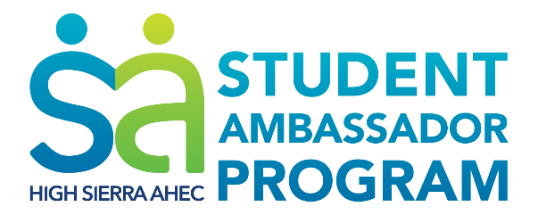

1st Annual

Pre-Professional Healthcare Workforce Conference
April 7-8, 2017; University of Nevada, Reno
Friday, April 7th

1-1:50 PM
Loan Repayment Panel  WICHE Program; National Health Service Corps, Division of Public & Behavioral Health; NV Primary Care Office | Eating Disorders and Recovery  Kat Geiger, Clinical Director, Center of Hope
2-2:50 PM
What is Clinical Psychology? Degrees and Achievements  Tony Papa, PhD  UNR Clinical Psychology Program | Civic Engagement: Opening Doors and Opportunities (GivePulse)  Amy Koeckes and Chris Partridge, UNR Center for Student Engagement
3-3:50 PM
Cardiology, As Practice in Northern Nevada  David Smith, MD | Nevada and the Affordable Care Act  Heather Korbulic, Nevada Silver State Exchange
The Physician Assistant (PA) Education and Profession
Brian Lauf, MPAS, PA-C, DFAAPA, Founding PA Program Director
4-4:50 PM
Careers in Medicine Today: Primary Care  Marcia Lu, MD, Assistant Professor and Clerkship Director, UNR School of Medicine | Careers in Medicine Today: Dermatology  Frank Stadler, MD, Skin Care and Dermatology Institute
Population Health: 360 Degrees of Managing Health
Chris Needham, Director of Member Health & Wellness, Renown Health
5-7 PM
Catering provided by Paisan’s Old World Deli and High Sierra AHEC
Keynote and Networking Dinner:
Family Practice in Nevada
Bonnie Ferrara, MD, UNR Family Medical Center
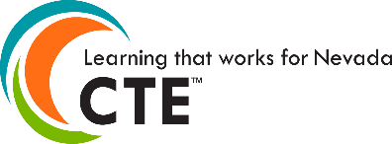
Saturday, April 8th

9-9:50 AM
Breakfast provided by Rounds Bakery and High Sierra AHEC
The New, Connected Healthcare System  Kirk Gillis, Vice President, Renown Health | Telehealth in Nevada  Chris Marchand, MPH, Project ECHO Program Coordinator
10-10:50 AM
Women’s Health & Health Policy  Daela Gibson, Planned Parenthood | Stitch Like a Surgeon: Suturing Workshop  Medical Education and Outreach Committee, UNR School of Medicine
Childhood Obesity Prevention & Treatment in a Community Health Center
Steven Shane, MD, Pediatrician, Community Health Alliance
11-11:50 AM
Pathology: The Black Box of Medicine  Grant Hayashi, MD, Diagnostic Pathology Medicine Group | Medical School Q&A Panel  Medical Education and Outreach Committee, UNR School of Medicine
12-12:50 PM
Lunch & Learn Sessions ~ Support local food trucks or bring a lunch!
Career and Technical Education: College and Career Readiness  Randi Hunewill, Assistant Director CTE | LGBTQ+ Health Spotlight  Jeromy Manke, PHR, SHRM-CP, Director of Our Center
1-1:50 PM
Interprofessional Education: Collaborative Care Panel  Reema Naik, VOICE Founder | Premedical Financial Preparation  Jodi Shpargel and Leonard Walker  UNR School of Medicine
Project Prevent 2.0 Workshop
Physical Health and Wellness
Vanessa Morales, High Sierra AHEC Intern
2-2:50 PM
Snacks provided by Great Full Gardens and High Sierra AHEC
Careers in Medicine Today: Nursing, the Most Trusted Profession  Erin VanKirk, RN, Director of Nursing Education, Renown Health | Careers in Medicine Today: Anesthesia  Hak Sun Bak, MD,  Northern Nevada Anesthesia Associates
3-3:50 PM
Careers in Medicine Today: Anesthesia  Hak Sun Bak, MD  Northern Nevada Anesthesia Associates | Project Prevent 2.0 Workshop  Physical Health and Wellness  Vanessa Morales, High Sierra AHEC Intern
4-4:50 PM
Work-Life Balance – A Moving Target  Marc Montella, MD, Reno Radiological Associates | Careers in Medicine Today: Emergency Medicine  Wayne Mackey, Advanced EMT, REMSA

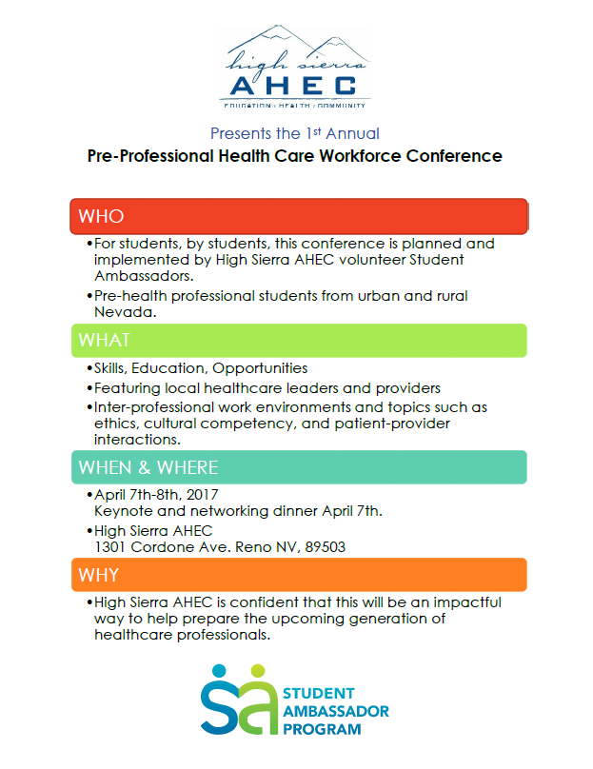
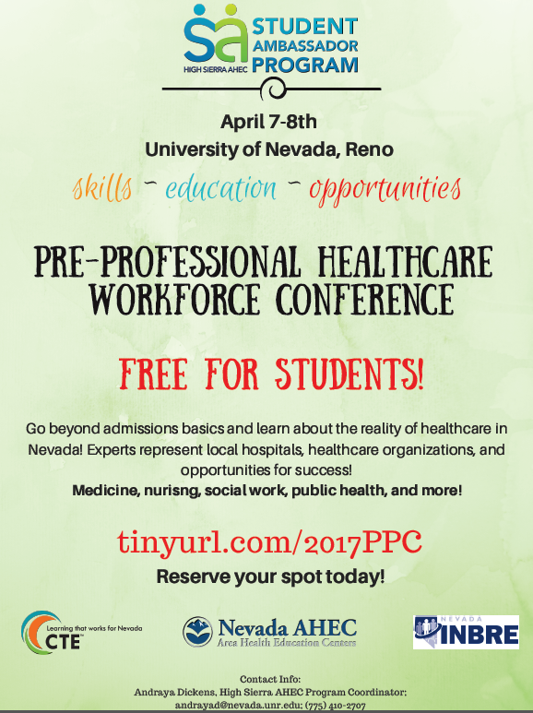
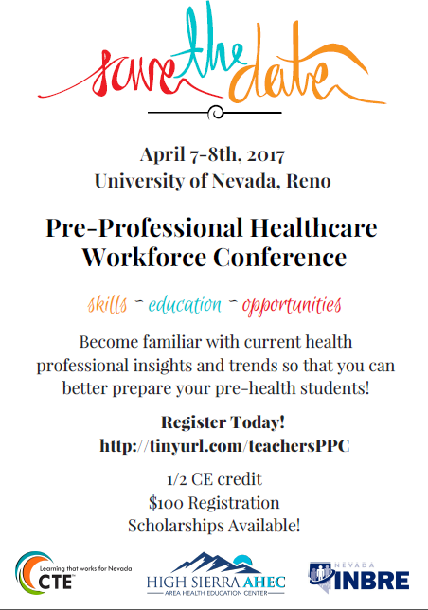
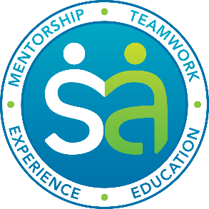

To our dedicated community members, the Student Ambassadors of High Sierra Area Health Education Center (AHEC) invite you to join us for our first annual Pre-Professional Healthcare Workforce conference keynote and networking dinner April 7th from 5-7pm at the University of Nevada, Reno!
Volunteer Ambassadors have dedicated their time and enthusiasm to recruit and organize 28 local healthcare leaders and practitioners to share their experience and expertise in order to better prepare the future of healthcare – and to keep the experience FREE for students! Beyond these incredible sessions, Bonnie Ferrara, MD, a UNR Family Medicine Center resident doctor, will be kicking off the keynote and networking dinner!
We are excited to see all this hard work come to life and to share it with our community! Encourage these students to build a network, pursue their dreams, and take the next step towards success. Dinner attendance is limited, so please register today! (tinyurl.com/2017PPC)
To learn more about these incredible students and our journey, please visit our GoFundMe campaign video: https://www.gofundme.com/hsahec or contact HS AHEC Program Coordinator, Andraya Dickens (andrayad@nevada.unr.edu or by phone: 775.338.8854).
Invest your time and expertise to help prepare the best healthcare workforce of Northern Nevada!
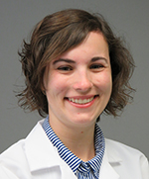
Family Practice in Nevada
April 7th, 5-7pm, University of Nevada, Reno
Dinner begins at 6pm; space is limited.
Born and raised in Sonoma County, CA, Bonnie Ferrara, MD, learned to suture by sewing up chickens and other animals that came across their doorstep. She attended the University of California, Riverside, obtaining her degree in Biochemistry, and continued to on to the UCLA Medical School. Currently a third year family medicine resident with the University of Nevada, Reno, Dr. Ferrara is also working on a Master’s in Public Health.
Register today! Tinyurl.com/2017PPC

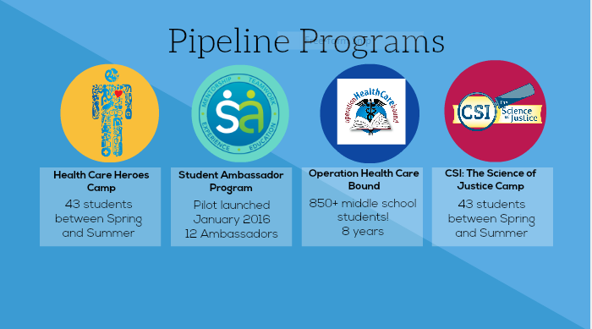
Health Care Heroes and CSI: The Science of Justice are week-long, all-day science camps hosted in collaboration with Extended Studies at the University of Nevada, Reno.

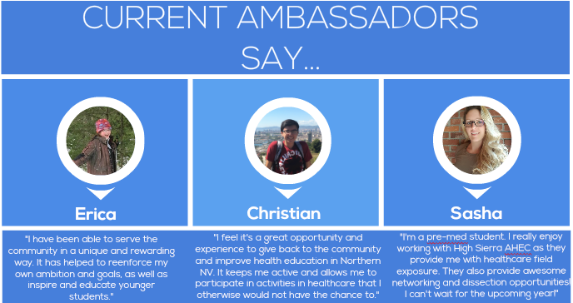

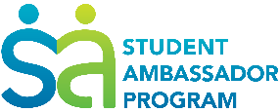
High Sierra AHEC Student Ambassador Program
GREAT OPPORTUNITY FOR:
- DHS MAJORS
- PREMED MAJORS
- STEM TEACHERS
- Anyone interested in volunteering in our community!
DIVERSE & FLEXIBLE:
- High Sierra AHEC collaborates with many community partners while maintaining non-profit work, creating a diverse work environment. There is always something new to delve into!
- Student volunteers and interns are indispensable to AHEC’s operations and mission! Your education and experience is imperative, so we do our best to be flexible with dedicated students.
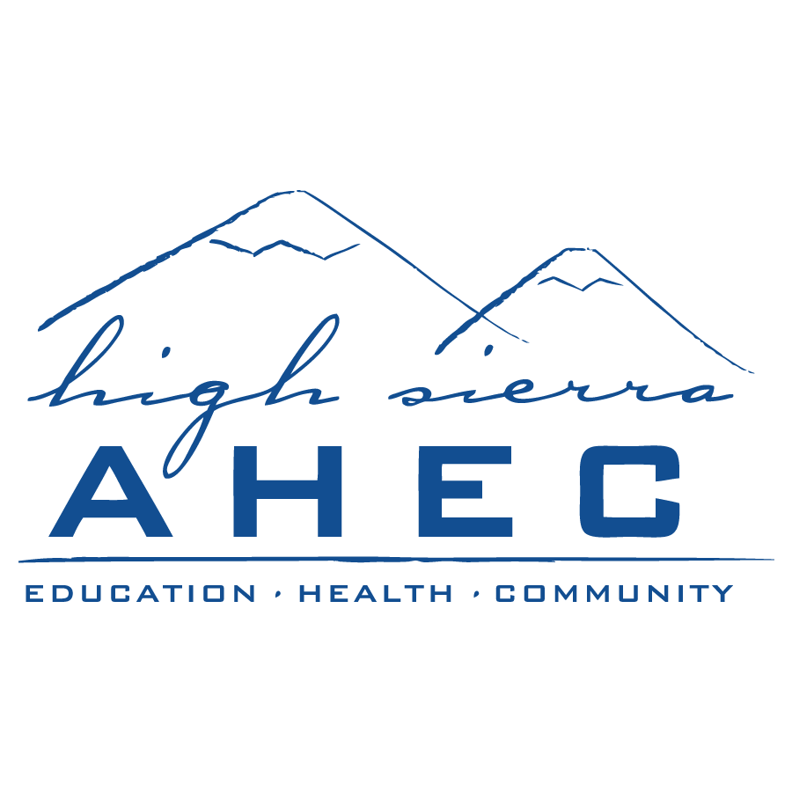

GOAL/MISSION
To build a team of diligent, enthusiastic community leaders who promote the mission of High Sierra AHEC:
- Health care workforce development
- Health care workforce diversity
- Transformation of health care delivery
STUDENT AMBASSADOR TASKS
- Program preparation and implementation, including teaching
- Curriculum development for science enrichment camps
- Development of community-based health outreach events
- Social media engagement
- Student Ambassador Program promotion
SKILLS LEARNED/PRACTICED
- Non-profit experience
- Team building and teamwork
- Teaching experience
- Curriculum design
- Program planning & management
HOW TO APPLY & REQUIREMENTS
- Fill out our online application
- Attend orientation
- Participate in 3 HS AHEC events & attend monthly Ambassador meetings
APPLY NOW: tinyurl.com/HSAHECstudentambassador

BONUS: Added benefit opportunities for professional development & health care workforce engagement; events vary by semester.
CONTACT INFORMATION
Andraya Dickens, Program Coordinator
andrayad@nevada.unr.edu
(775) 410-2707
1301 Cordone Avenue, Suite LL-40, Reno NV 89502

High Sierra AHEC | HighSierraAHEC.org

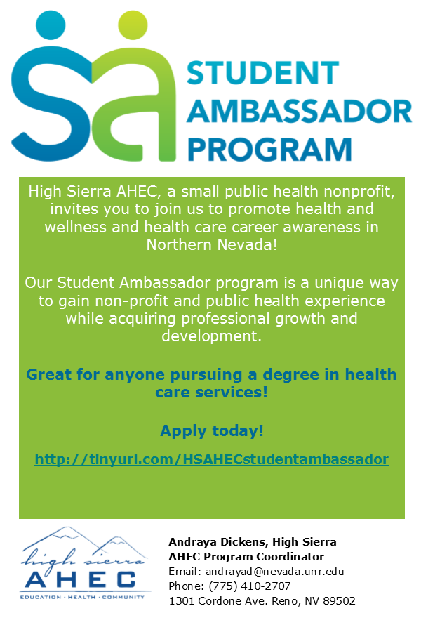
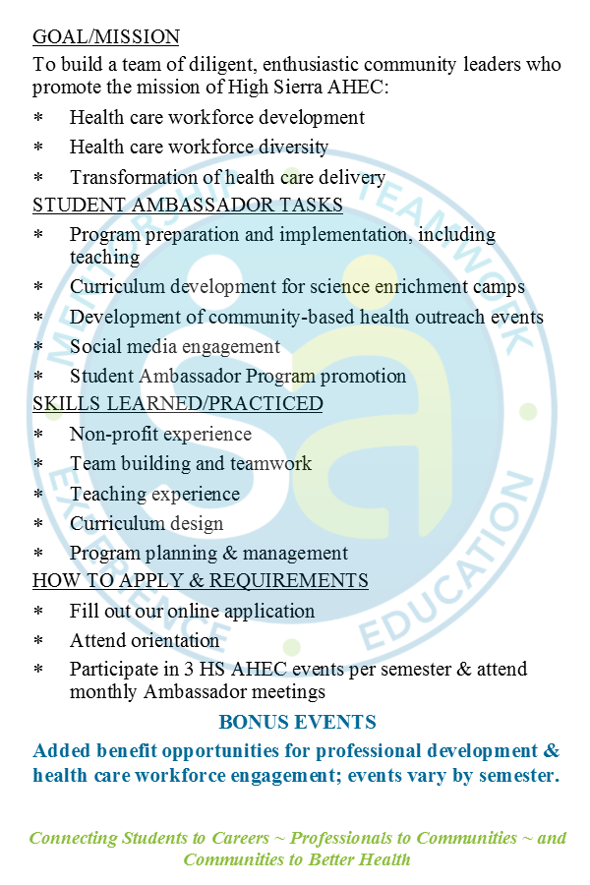
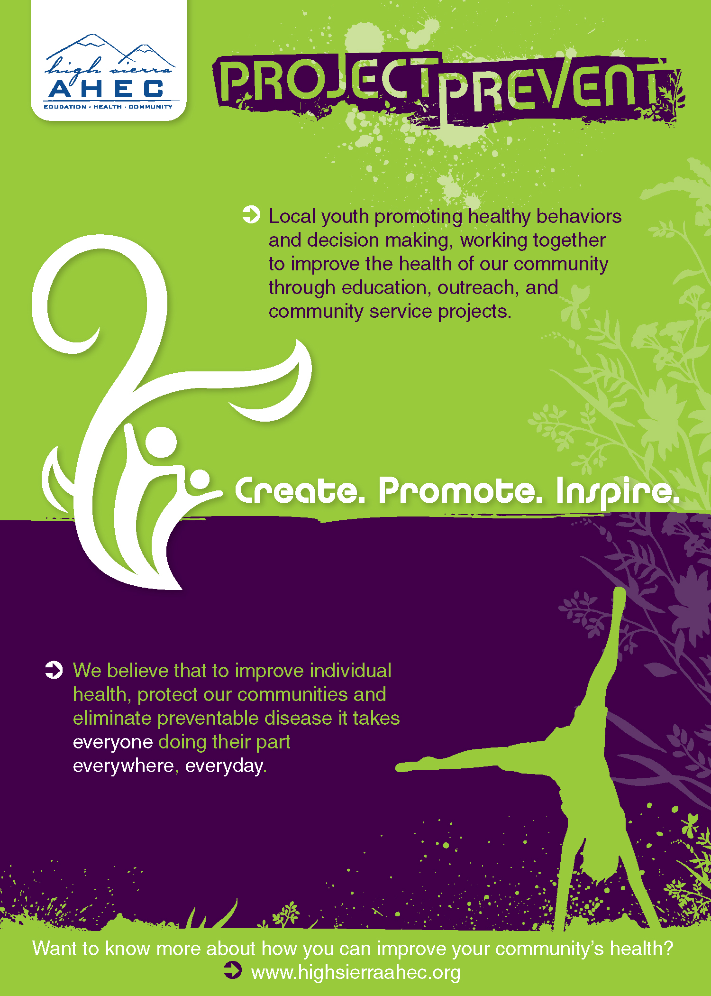Project Prevent is currently implemented bi-annually in two under-served and high risk high schools in Washoe County as a week-long curriculum that explores the 8 Dimensions of Wellness.
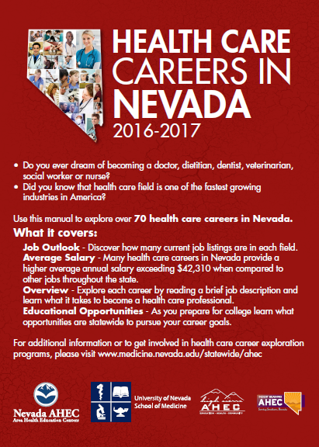

The Health Care Careers Manual is utilized in schools, colleges, and universities across Nevada as a career exploration tool, and by HS AHEC staff and Ambassadors during Discovering Health Careers presentations in local schools. An interactive PDF version can be found here or on our website at www.highsierraahec.org.

