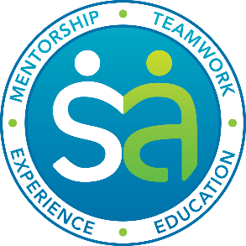

To our dedicated community members, the Student Ambassadors of High Sierra Area Health Education Center (AHEC) invite you to join us for our first annual Pre-Professional Healthcare Workforce conference keynote and networking dinner April 7th from 5-7pm at the University of Nevada, Reno!
Volunteer Ambassadors have dedicated their time and enthusiasm to recruit and organize 28 local healthcare leaders and practitioners to share their experience and expertise in order to better prepare the future of healthcare – and to keep the experience FREE for students! Beyond these incredible sessions, Bonnie Ferrara, MD, a UNR Family Medicine Center resident doctor, will be kicking off the keynote and networking dinner!
We are excited to see all this hard work come to life and to share it with our community! Encourage these students to build a network, pursue their dreams, and take the next step towards success. Dinner attendance is limited, so please register today! (tinyurl.com/2017PPC)
To learn more about these incredible students and our journey, please visit our GoFundMe campaign video: https://www.gofundme.com/hsahec or contact HS AHEC Program Coordinator, Andraya Dickens (andrayad@nevada.unr.edu or by phone: 775.338.8854).
Invest your time and expertise to help prepare the best healthcare workforce of Northern Nevada!

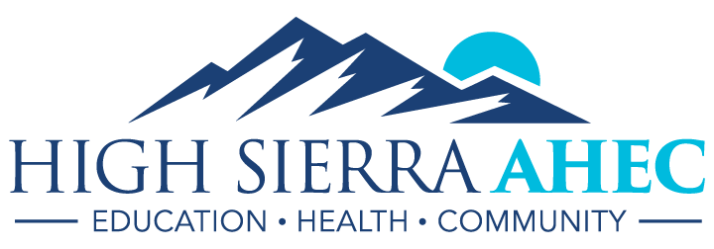

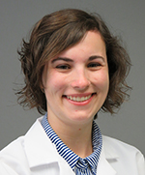
Family Practice in Nevada
April 7th, 5-7pm, University of Nevada, Reno
Dinner begins at 5pm; space is limited.
Born and raised in Sonoma County, CA, Bonnie Ferrara, MD, learned to suture by sewing up chickens and other animals that came across their doorstep. She attended the University of California, Riverside, obtaining her degree in Biochemistry, and continued to on to the UCLA Medical School. Currently a third year family medicine resident with the University of Nevada, Reno, Dr. Ferrara is also working on a Master’s in Public Health.
Register today! Tinyurl.com/2017PPC

