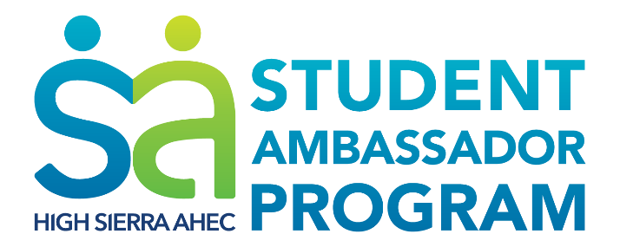

You’re Invited!
Join High Sierra Area Health Education Center (AHEC) and volunteer Student Ambassadors for a 2-day Pre-Professional Healthcare Workforce Conference!
April 7-8th, University of Nevada, Reno
Go beyond admissions basics and learn about the reality of healthcare in
Nevada! Over 25 experts represent local hospitals, healthcare organizations, and
opportunities for success!
Medicine, nurisng, social work, public health, and more!
FREE FOR STUDENTS!
Reserve your spot today!
Tinyurl.com/2017PPC

Keynote and networking dinner:
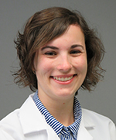
Family Practice in Nevada
April 7th, 5-7pm, University of Nevada, Reno
Dinner begins at 5pm; space is limited.
Born and raised in Sonoma County, CA, Bonnie Ferrara, MD, learned to suture by sewing up chickens and other animals that came across their doorstep. She attended the University of California, Riverside, obtaining her degree in Biochemistry, and continued to on to the UCLA Medical School. Currently a third year family medicine resident with the University of Nevada, Reno, Dr. Ferrara is also working on a Master’s in Public Health.
Register today! Tinyurl.com/2017PPC
