September 8th Meeting Notes

- Missing a meeting?
- Let Andraya and the Leads know, send an email or message all 3 on Slack
- Get in touch with Christian or Camarina to get the meeting notes & any important updates
2. Slack
- Slack is the new platform we will be using to communicate. It is more efficient than using regular e-mail. Through Slack you are able to direct message people, from different channels, and upload files. Everyone should download the app. Our group is AHECSA

3. Social Media Takeover
- We really want to expand our brand and market the student ambassador program. It is important that more people know about us, what we have to offer, and the great work that we do.
- “Like” us on Facebook
- “Like” us on Instagram: highsierraahec
- Comment, share, and tag High Sierra AHEC during events, meetings, and more!
- Post live videos, boomerangs, pictures
- Ideas for postings: What dimension of health or wellness are you practicing
- Like, comment, share, interact when other ambassadors post
- Keep it professional

4. Ambassador Socials
- September 22nd: Board Game & Snack Potluck Night
- October 20th: Rock Climbing or Jumpy Place
- December 13th: Hot Cocoa & Secret Santa Social
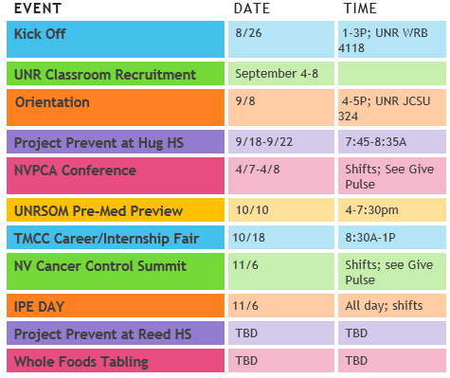
5. Fall 2017 Highlights
- Here the events we will be participating in for this semester
- Remember you have to participate in three events
- Sign up for volunteer shifts through GivePulse

6. Bonus Events: Make sure to take advantage of the bonus events we have to offer!

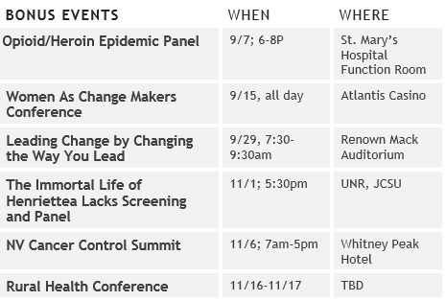

7. Focus for this semester
- Interprofessional Education
- Professional Development
- Community Collaboration
- Wellness

If you have any questions just please let me, Christian, or Andraya know through Slack! Thanks!

